Selenium_njdg

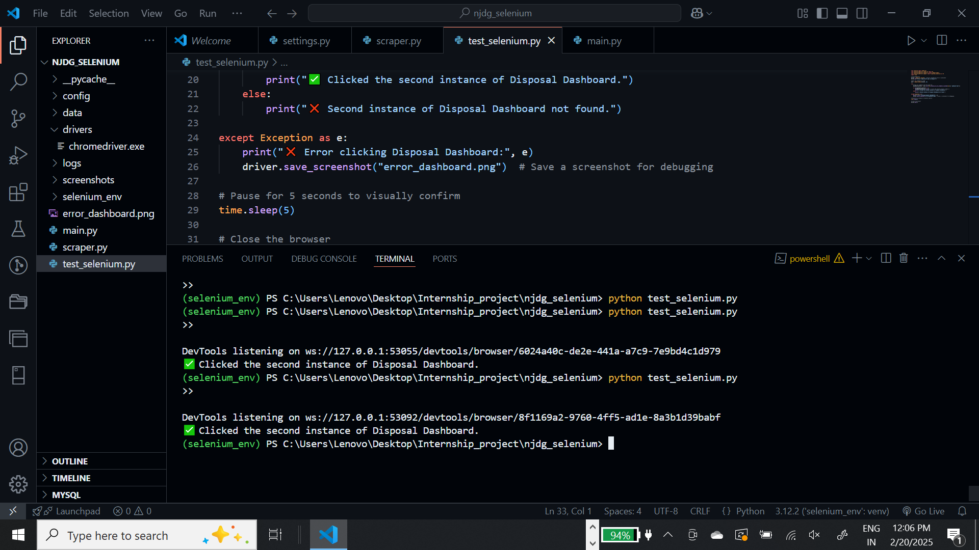

<button class="btn btn-primary float-end btn-sm" id="agewisechartbtn" aria-label="click to view data in graphical form" style>

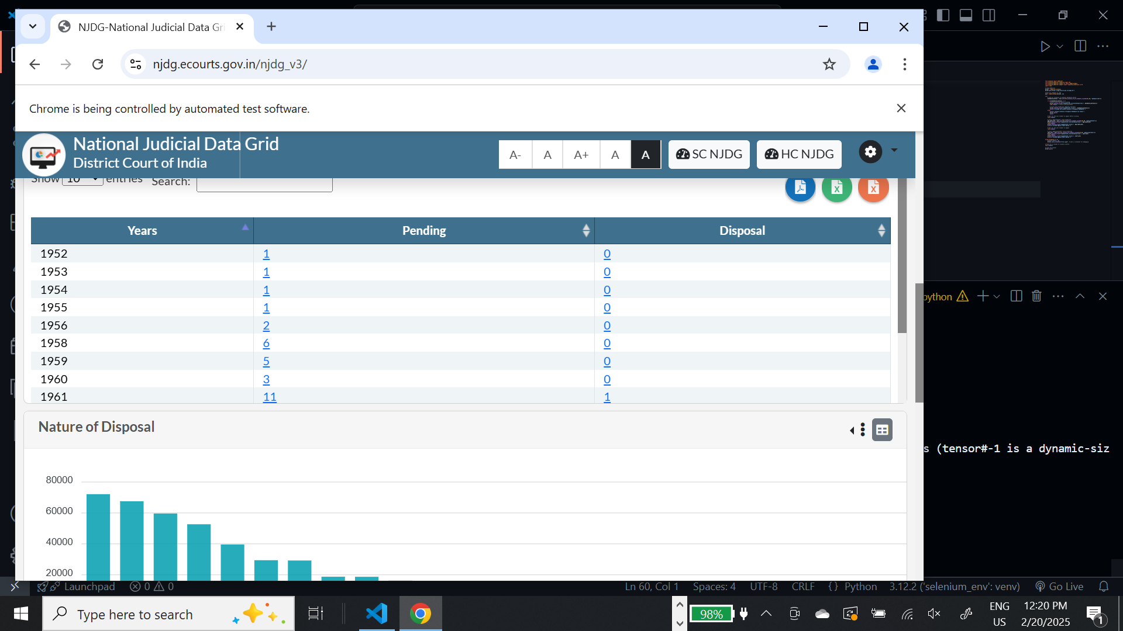

<td class="sorting_1">2024</td>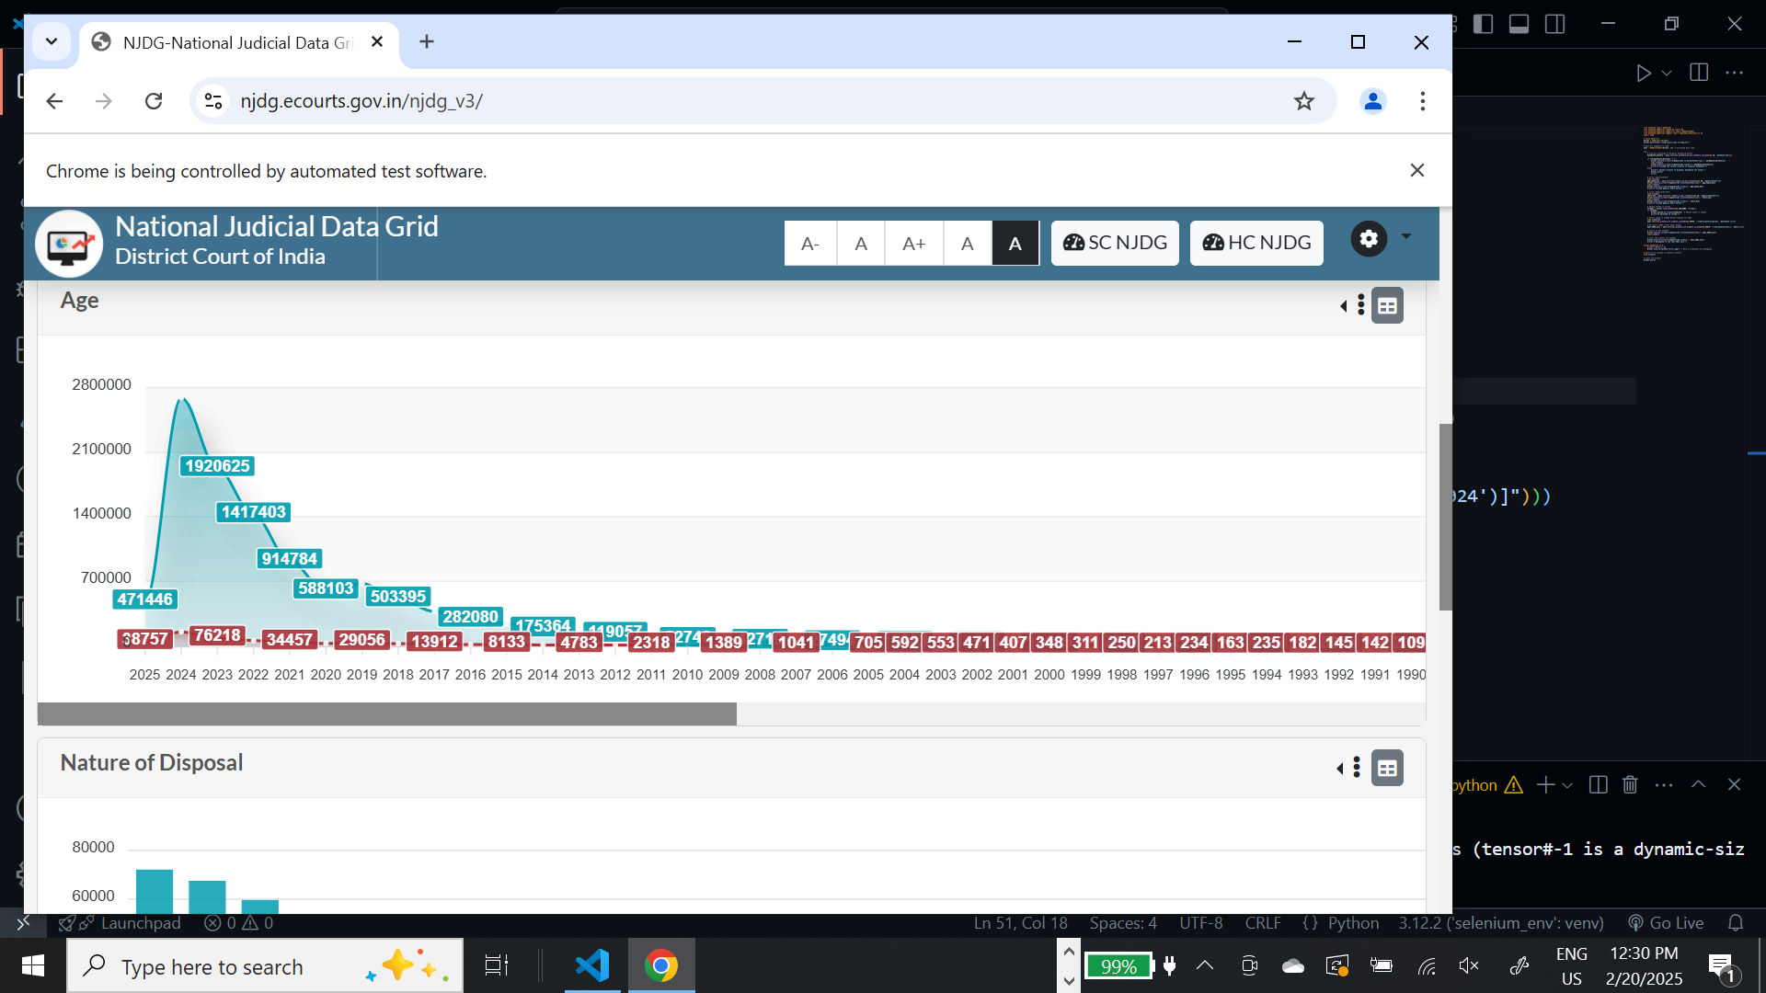

<div id="tblAgewisecount_filter" class="dataTables_filter">…</div>

<div id="tblAgewisecount_filter" class="dataTables_filter">

<a href="#" onclick="javascript:estwise_case_details("29~3","20","2","disposed","2024","dispAgeYear")" ; data-bs-toggle="modal" data-bs-target="#modal_estwiseCase_data">32651</a>

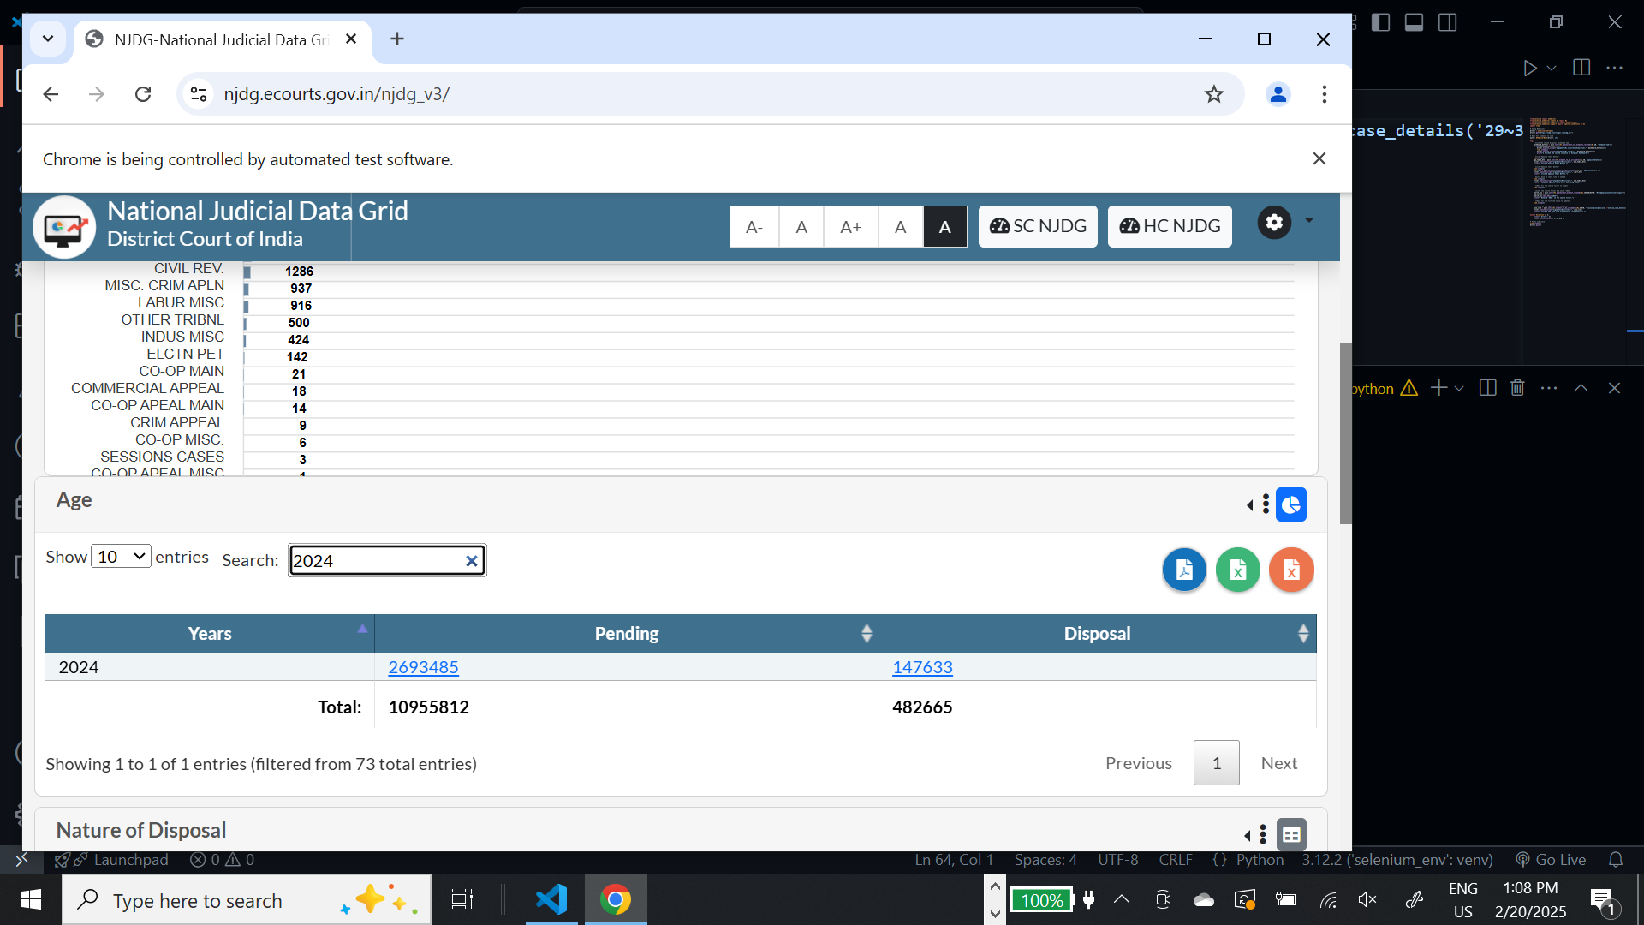

<a href="#" onclick="javascript:statewise_case_details("","","2","disposed","2024","dispAgeYear")" ; data-bs-toggle="modal" data-bs-target="#modal_statewiseCase_data">2693485</a>

<a href="#" onclick="javascript:statewise_case_details("","","2","disposed","2024","dispAgeYear")" ; data-bs-toggle="modal" data-bs-target="#modal_statewiseCase_data">2693485</a>

<a href="#?app_token=005434201e73c904fff042b174769502af15b7677753f983a6189ac3c5da3249" onclick="javascript:estwise_case_details("29~3","20","2","disposed","2024","dispAgeYear")" ; data-bs-toggle="modal" data-bs-target="#modal_estwiseCase_data">32651</a>

<div id="tblStatewisecount_wrapper" class="dataTables_wrapper">

<div id="tblStatewisecount_filter" class="dataTables_filter">

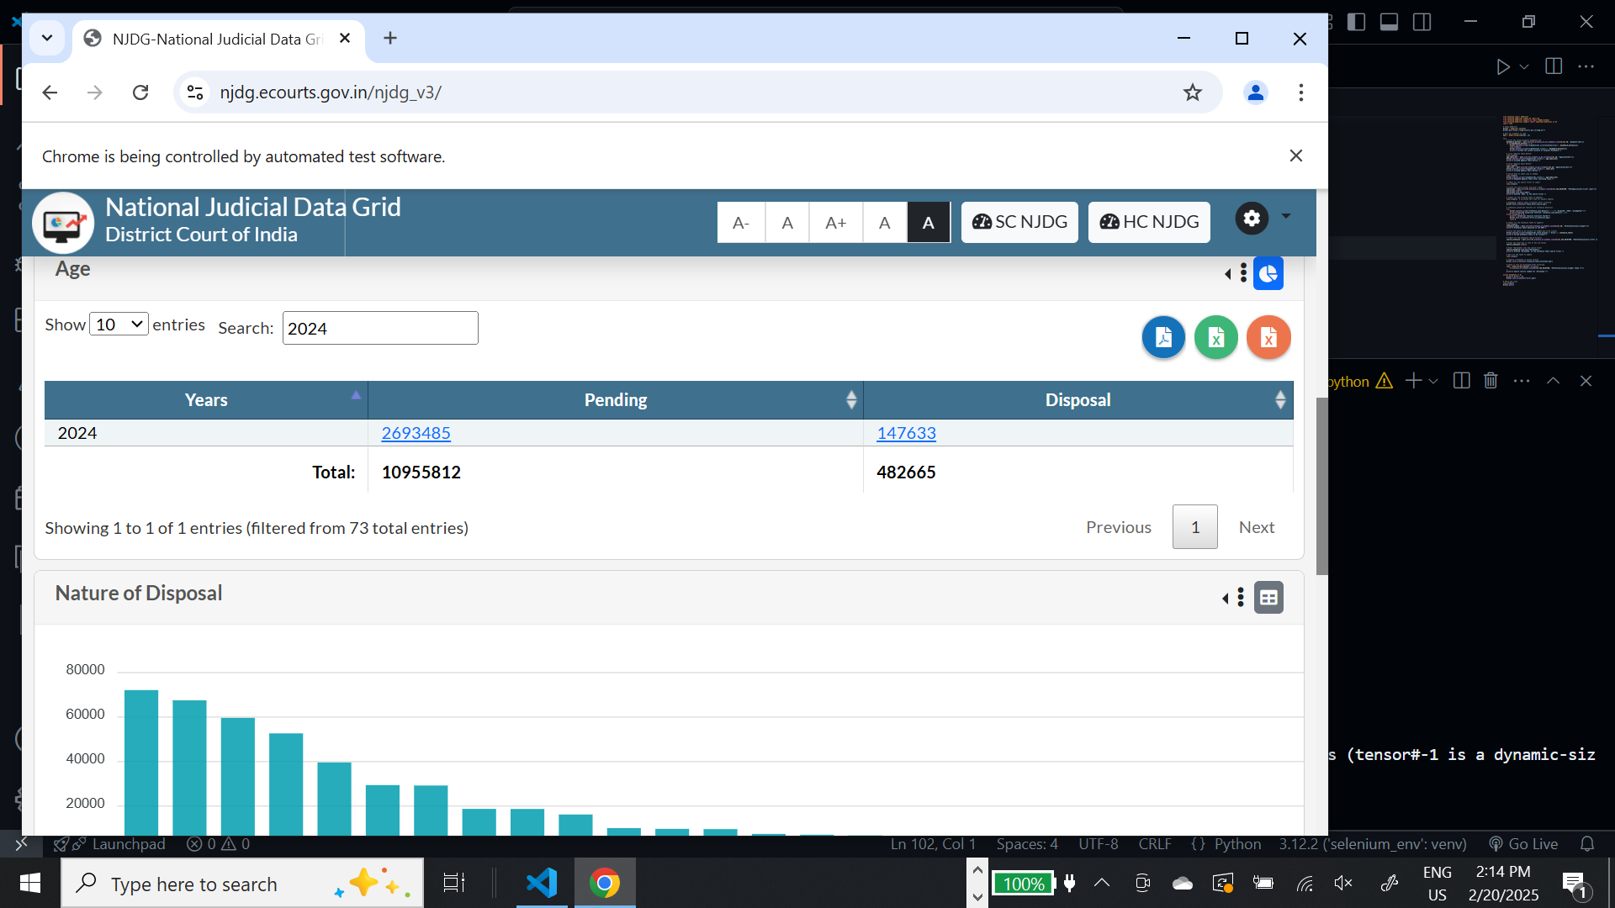

<div class="modal fade show" id="modal_statewiseCase_data" data-bs-backdrop="static" data-bs-keyboard="false" tabindex="-1" aria-labelledby="staticBackdropLabel" aria-modal="true" role="dialog" style="display: block;">…</div>

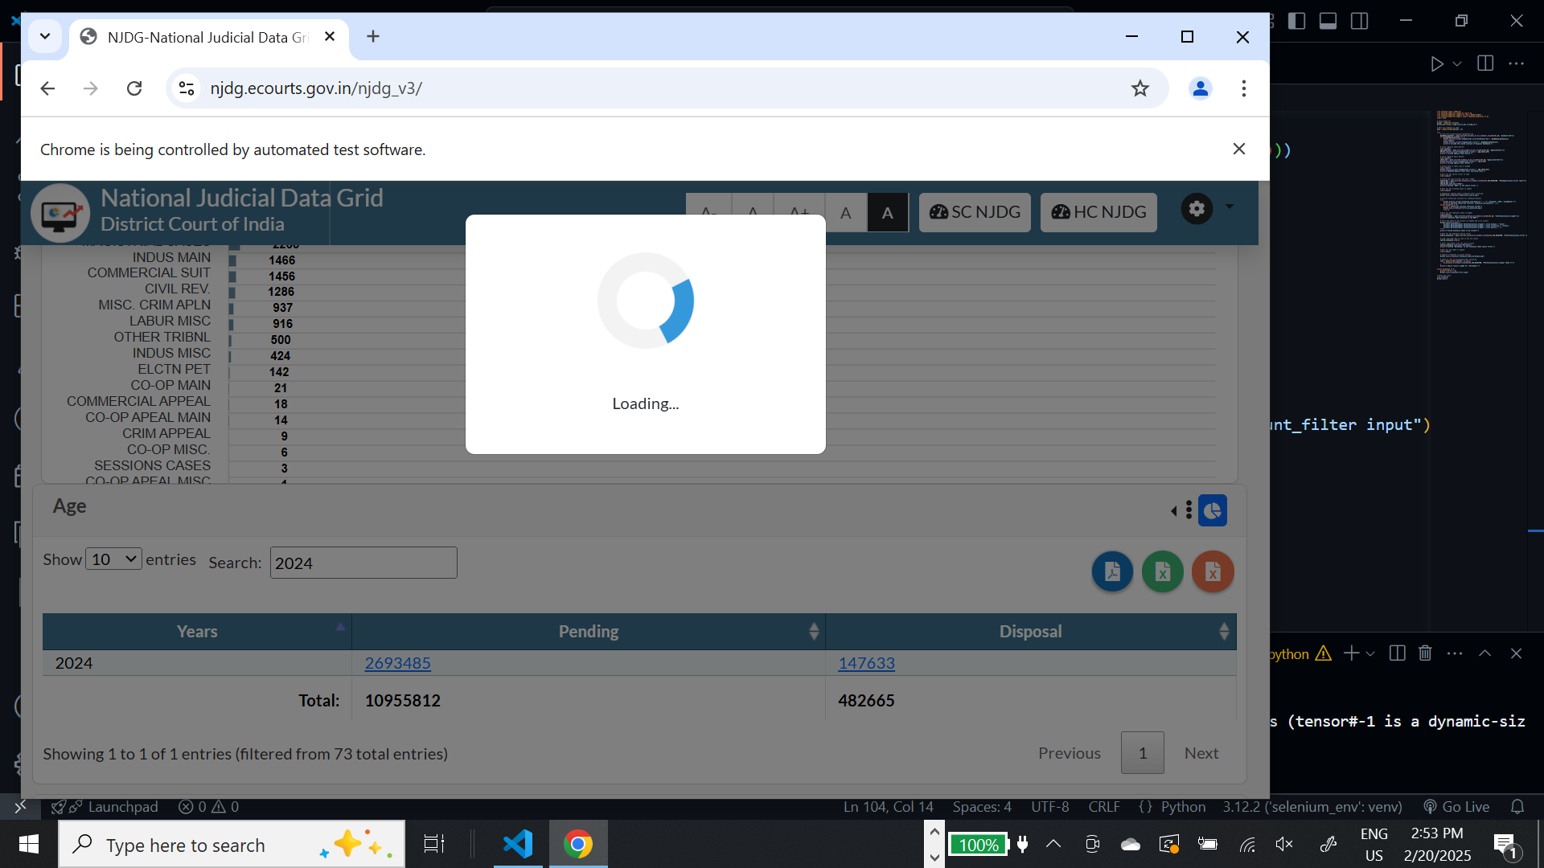

<a href="#?app_token=c029289daade2464874e0dceffffd6c4251e17bccba1247e198dd90bda8798fe" onclick="javascript:statewise_case_details("","","2","disposed","2024","dispAgeYear")" ; data-bs-toggle="modal" data-bs-target="#modal_statewiseCase_data">2693485</a>

<div class="dataTables_length" id="tbldistwisecount_length">…</div>

<table id="tblStatewisecount" class="table table-bordered bg-light dataTable" style="width:100%" aria-describedby="tblStatewisecount_info">

<a href="#" onclick="javascript:statewise_case_details("","","2","disposed","2024","dispAgeYear")" ; data-bs-toggle="modal" data-bs-target="#modal_statewiseCase_data">2693485</a>

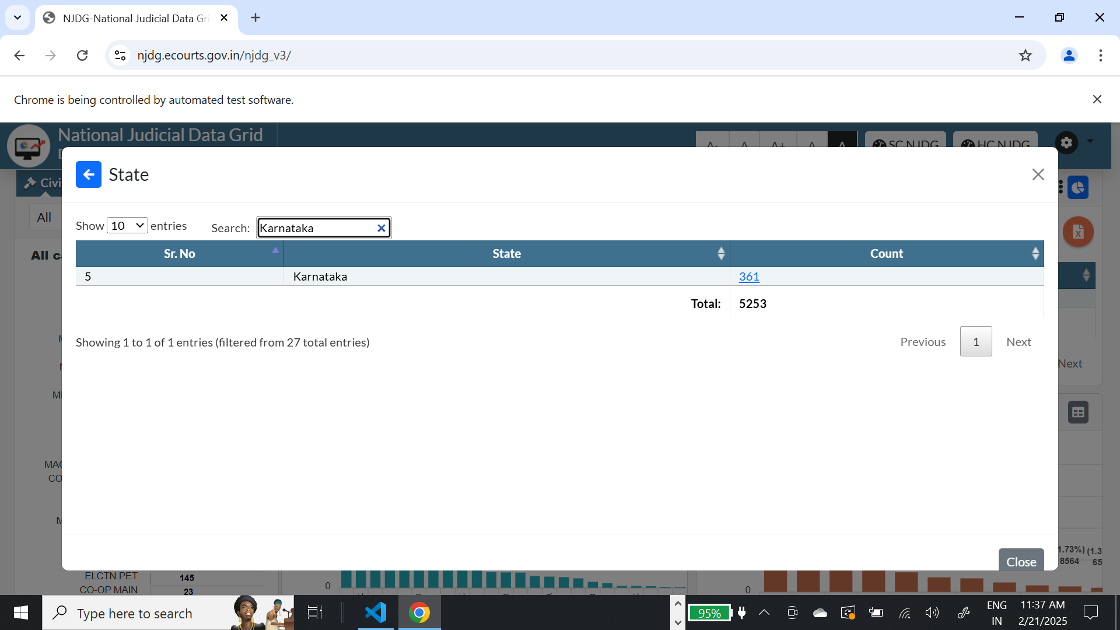  
  
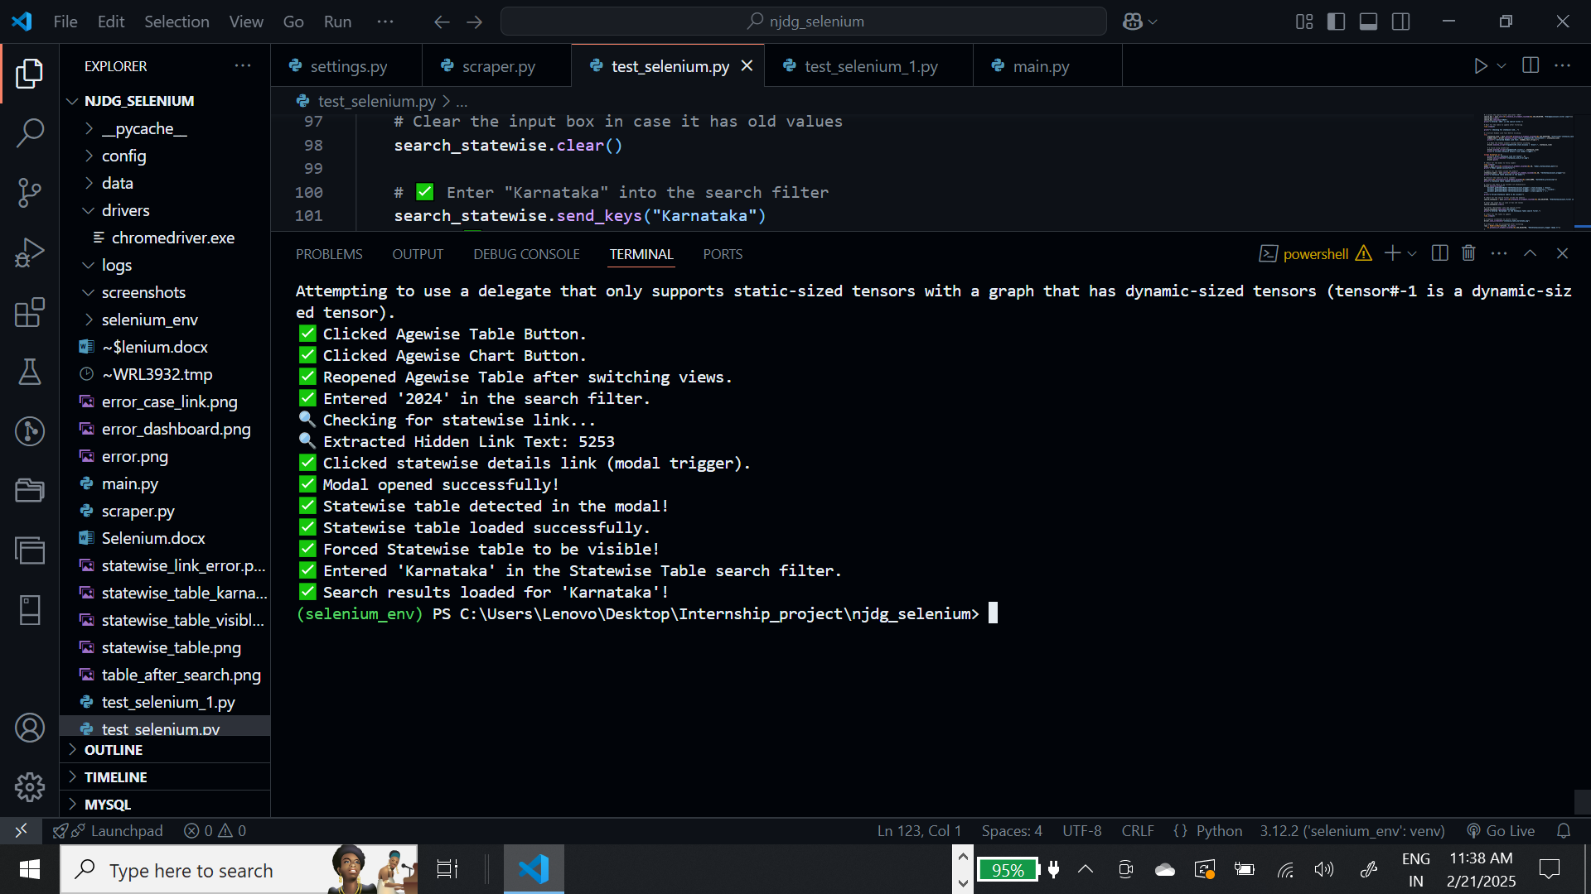

<a href="#" onclick="javascript:distwise_case_details('29','','2','disposed','2024','dispAgeYear','undefined','undefined','undefined')" ; data-bs-toggle="modal" data-bs-target="#modal_distwiseCase_data">267481</a>

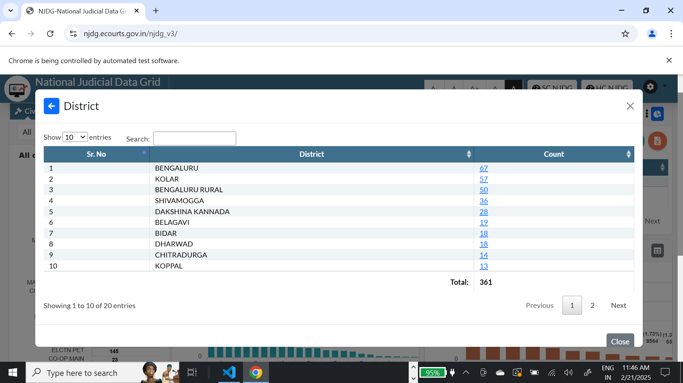  
  
<div id="tbldistwisecount_filter" class="dataTables_filter">

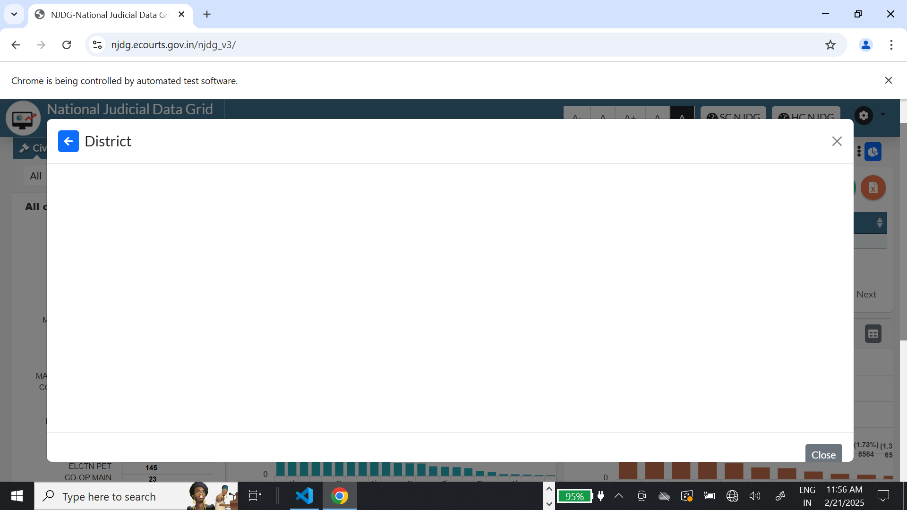

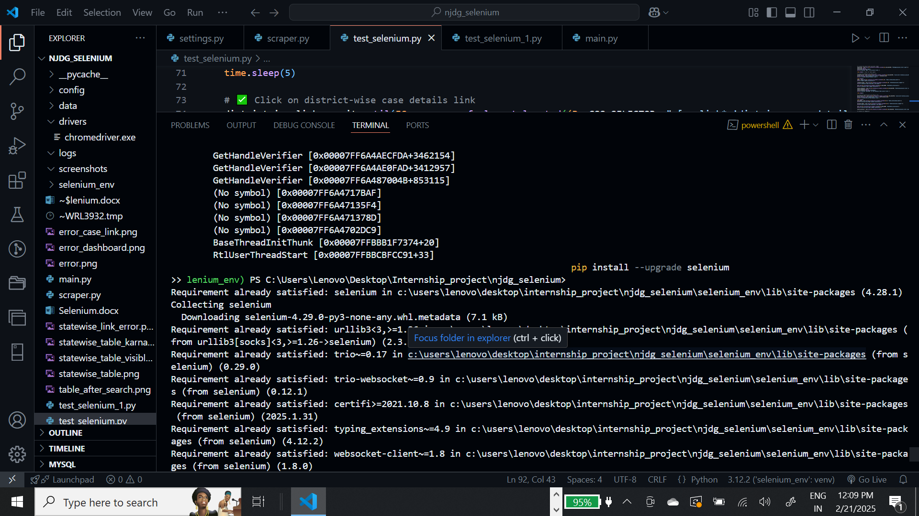

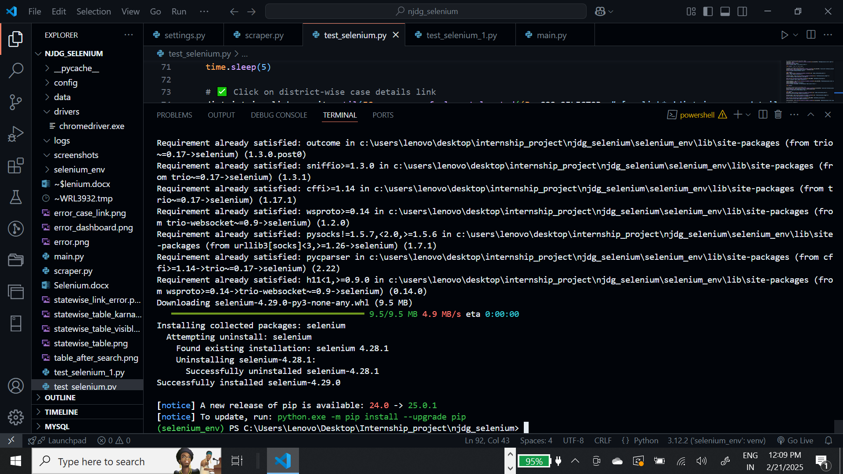

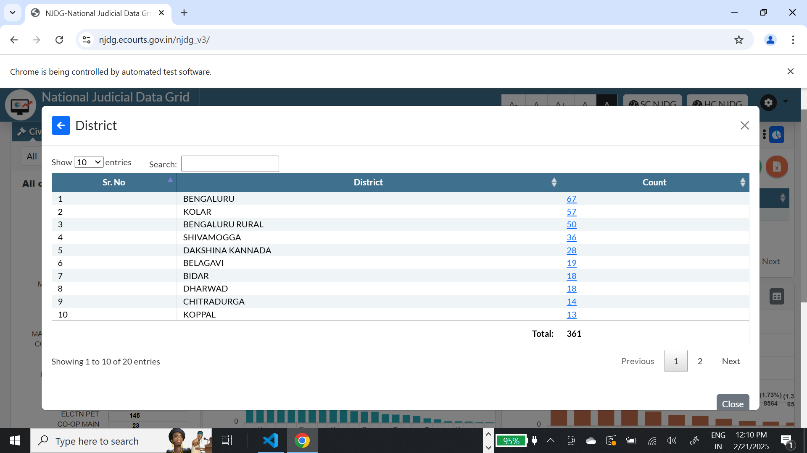

<div id="tbldistwisecount_filter" class="dataTables_filter">

<input type="search" class placeholder aria-controls="tbldistwisecount">

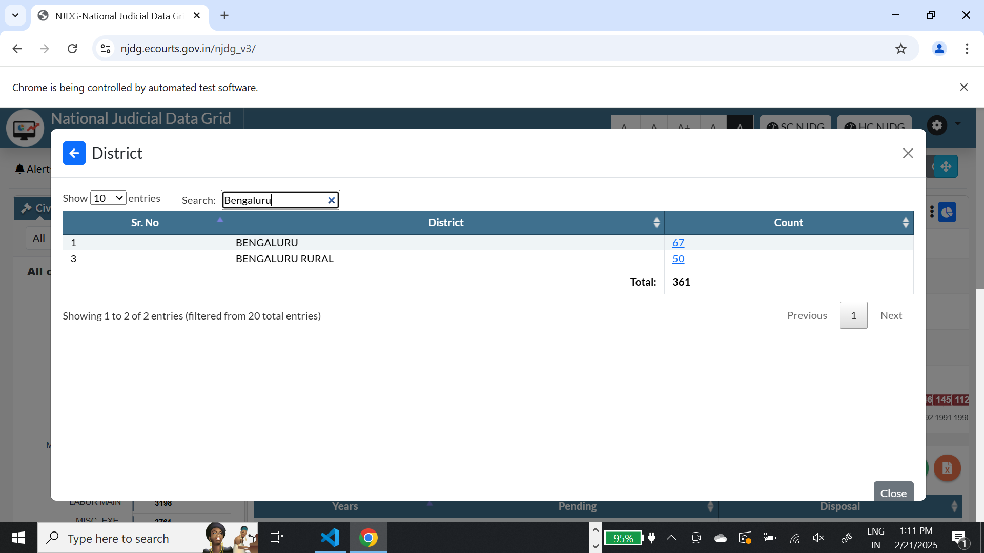

<a href="#" onclick="javascript:estwise_case_details('29','20','2','disposed','5007','casetype','undefined','undefined','')" ; data-bs-toggle="modal" data-bs-target="#modal_estwiseCase_data">67</a>

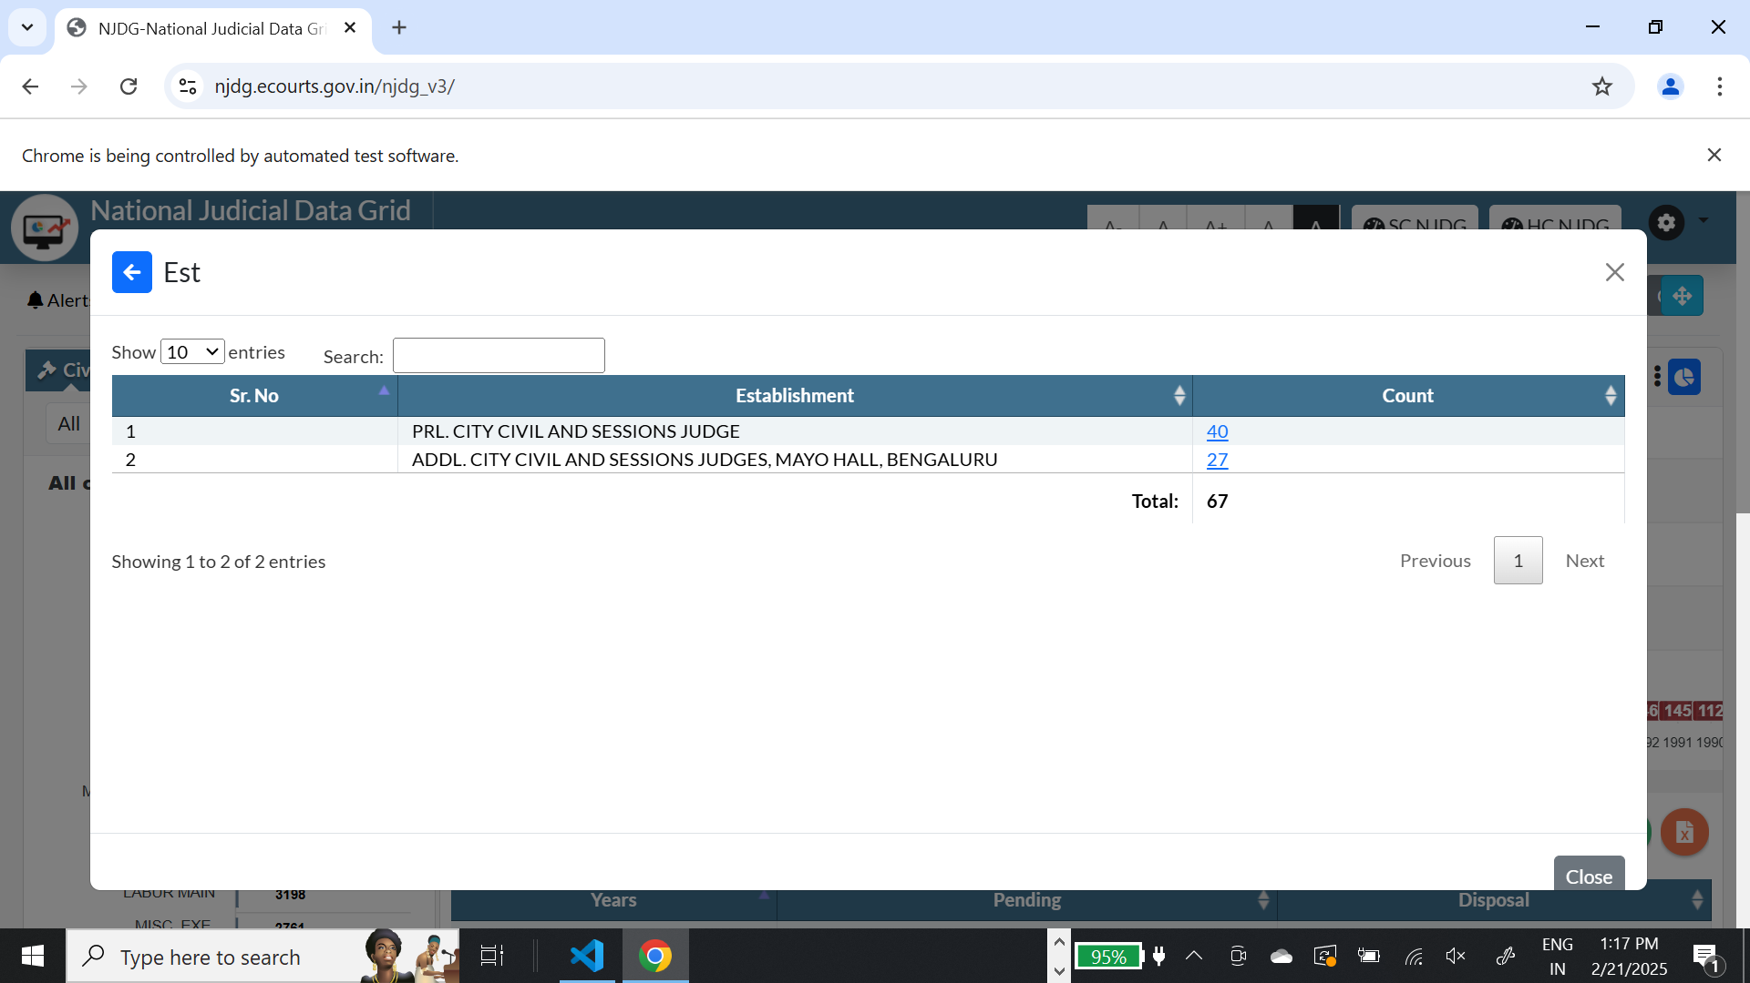

PRL. CITY CIVIL AND SESSIONS JUDGE

<div id="tblestwisecount_filter" class="dataTables_filter">

<a href="#" onclick="javascript:casewise_case_details('29','20','KABC01','2','disposed','5007','casetype','undefined','undefined','')" ; data-bs-toggle="modal" data-bs-target="#modal_dashcaselist">40</a>

prl. city civil and sessions judge

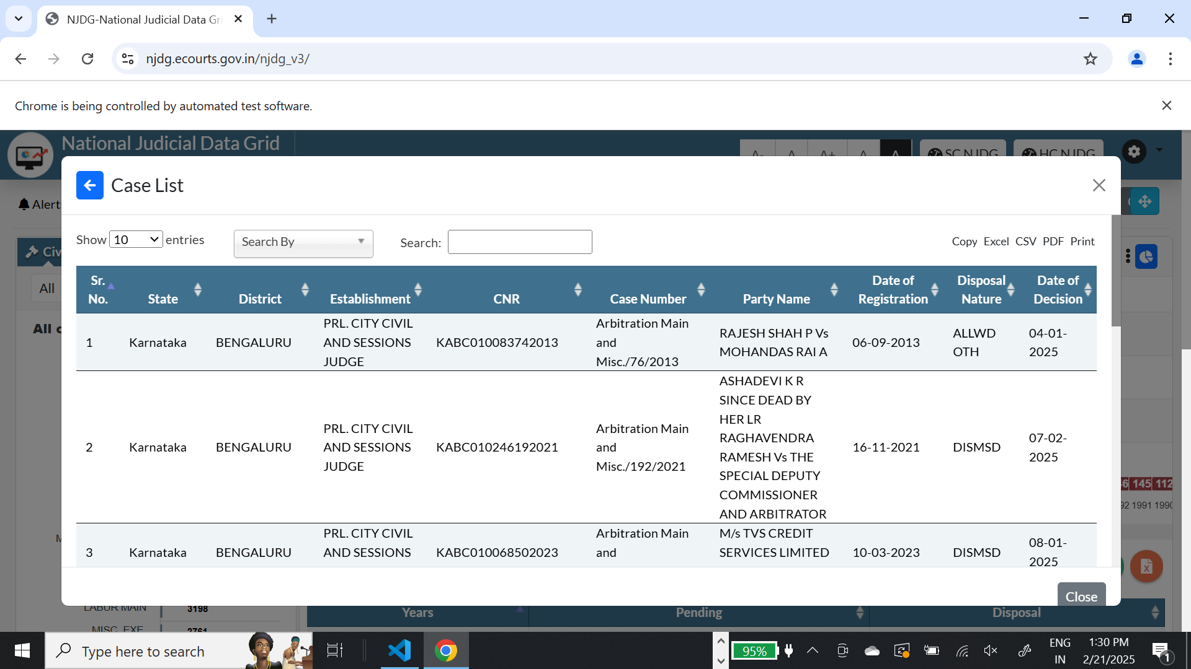

<a class="dt-button buttons-csv buttons-html5" tabindex="0" aria-controls="tbl_cases_dash" href="#">

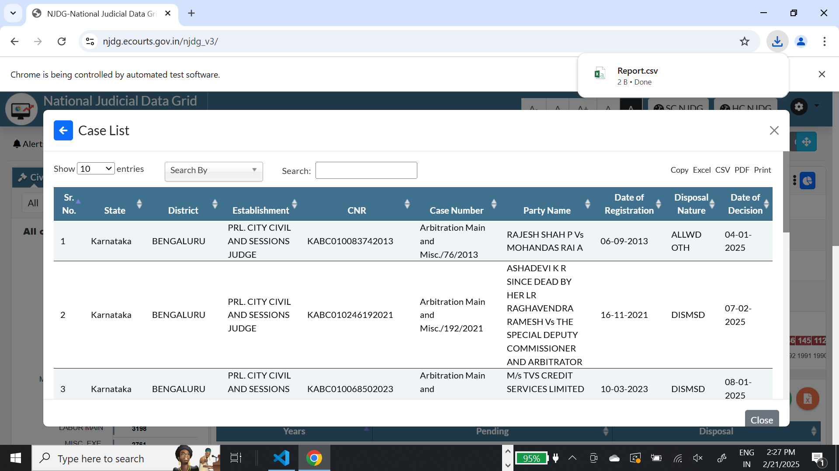

<a class="dt-button buttons-pdf buttons-html5" tabindex="0" aria-controls="tbl_cases_dash" href="#?app_token=1af50b48dec79a4b85d24fc7a2a73a0f1d025b361f7324b5a14b3b361e3ed274">…</a>

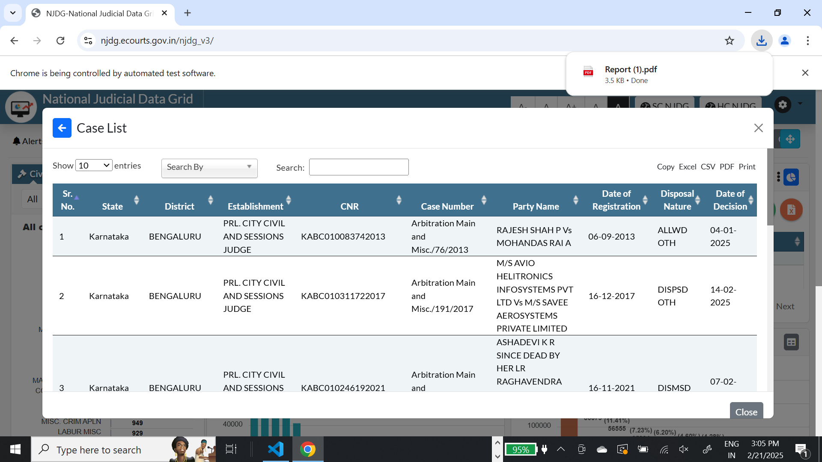

<div class="modal-body" id="modal-body-dashcaselist">scroll

<div class="modal-body" id="modal-body-dashcaselist">…</div>scroll

Steps I followed during the entirety of the project  
  
step 1:

Download all the dependencies such as Selenium,etc and install and activate a virtual environment I used “selenium_env”

Step 2:

* Look up your web driver version and then download the web driver from the normal web

I used the chromedriver as my webdriver and my web driver and my version was 132.0. something like that so I down loaded the webdriver   
  
https://storage.googleapis.com/chrome-for-testing-public/132.0.6807.0/win64/chromedriver-win64.zip

The version should be something like this

Step 3: Analyze and inspect the website you want to crawl

* It is important to know what you are dealing with so analysis and inspection of the code is important
* Ask ChatGPT for instruction on how to do it

Step 4:

* Start building and run
* Debug errors. It’s ok if face error. Solve and resolve them. If too tough to resolve them take a break, talk to a friend and try again

Step 5:

* Test your code
* If test passes scale up your code

<a class="paginate_button next" aria-controls="tbl_cases_dash" role="link" data-dt-idx="next" tabindex="0" id="tbl_cases_dash_next">Next</a>

<a class="paginate_button next disabled" aria-controls="tbl_cases_dash" aria-disabled="true" role="link" data-dt-idx="next" tabindex="-1" id="tbl_cases_dash_next">Next</a>

ADDL. CITY CIVIL AND SESSIONS JUDGES, MAYO HALL, BENGALURU

addl. city civil and sessions judges, mayo hall, bengaluru

<button type="button" class="btn btn-primary me-2 btn-sm" data-bs-dismiss="modal" aria-label="Back" data-bs-toggle="modal" data-bs-target="#modal_estwiseCase_data">

print(len("Showing 1 to 10 of 30 entries"))

a: str = "Showing 1 to 2 of 2 entries"

import re

a: str = "Showing 1 to 2 of 2 entries"

# Extract the substring

substring = a[-10:-8]

# Attempt to convert to an integer

try:

integer_value = int(substring)

print(integer_value)

except ValueError:

print(f"Error: Cannot convert '{substring}' to an integer.")

[

       Sr. No.: "1",

       State: "Karnataka",

       District: "BENGALURU",

       Establishment: "PRL. CITY CIVIL AND SESSIONS JUDGE",

       CNR: "KABC010143442022",

       Case Number: "Arbitration Main and Misc./116/2022",

       Party Name: "OBEGOWDA H K SINCE DEAD REP BY LRS RAVI H K Vs THE PROJECT DIRECTOR AND GENERAL MANAGER (TECHNICAL)",

       Date of Registration: "08-06-2022",

       Purpose Name: "ALLWD AFT",

       Next Date: "10-02-2025"

    ],

<thead>…</thead><th class="text-left sorting" tabindex="0" aria-controls="tbl_cases_dash" rowspan="1" colspan="1" style="width: 0px;" aria-label="Next Date: activate to sort column ascending: activate to sort column ascending">Next Date</th>

[{

Sr. No: 1,

Establishment: “ PRL. CITY CIVIL AND SESSIONS JUDGE”,

Count: [

    {

        "Sr. No.": "1",

        "State": "Karnataka",

        "District": "BENGALURU",

        "Establishment": "PRL. CITY CIVIL AND SESSIONS JUDGE",

        "CNR": "KABC010143442022",

        "Case Number": "Arbitration Main and Misc./116/2022",

        "Party Name": "OBEGOWDA H K SINCE DEAD REP BY LRS RAVI H K Vs THE PROJECT DIRECTOR AND GENERAL MANAGER (TECHNICAL)",

        "Date of Registration": "08-06-2022",

        "Disposal Nature": "ALLWD AFT",

        "Date of Decision": "10-02-2025"

    },]}]

<thead><tr><th class="sorting sorting_asc" tabindex="0" aria-controls="tblestwisecount" rowspan="1" colspan="1" aria-label="Sr. No: activate to sort column descending" style="width: 0px;" aria-sort="ascending">Sr. No</th>

</tr></thead>

 # ✅ Click City-wise case details

    districtwise_link = wait.until(EC.presence_of_element_located((By.CSS_SELECTOR, "a[onclick*='casewise_case_details']")))

    driver.execute_script("arguments[0].click();", districtwise_link)

    print("✅ Clicked Case-wise details link.")

    time.sleep(2)

    # ✅ Validate modal opens

    wait.until(EC.visibility_of_element_located((By.ID, "modal_dashcaselist")))

    print("✅ Case-wise Modal opened successfully!")

Give me the code in selenium for making json in form [{ Sr. No: 1, Establishment: “ PRL. CITY CIVIL AND SESSIONS JUDGE”, Count: [ { "Sr. No.": "1", "State": "Karnataka", "District": "BENGALURU", "Establishment": "PRL. CITY CIVIL AND SESSIONS JUDGE", "CNR": "KABC010143442022", "Case Number": "Arbitration Main and Misc./116/2022", "Party Name": "OBEGOWDA H K SINCE DEAD REP BY LRS RAVI H K Vs THE PROJECT DIRECTOR AND GENERAL MANAGER (TECHNICAL)", "Date of Registration": "08-06-2022", "Disposal Nature": "ALLWD AFT", "Date of Decision": "10-02-2025" },]}] and the fields are in <thead><tr><th class="sorting sorting_asc" tabindex="0" aria-controls="tblestwisecount" rowspan="1" colspan="1" aria-label="Sr. No: activate to sort column descending" style="width: 0px;" aria-sort="ascending">Sr. No</th> </tr></thead> for court it should give the following code # ✅ Click City-wise case details districtwise_link = wait.until(EC.presence_of_element_located((By.CSS_SELECTOR, "a[onclick*='casewise_case_details']"))) driver.execute_script("arguments[0].click();", districtwise_link) print("✅ Clicked Case-wise details link.") time.sleep(2) # ✅ Validate modal opens wait.until(EC.visibility_of_element_located((By.ID, "modal_dashcaselist"))) print("✅ Case-wise Modal opened successfully!") and continue it json extration normally

 {

        "Sr. No": 1,

        "Establishment": "prl. city civil and sessions judge",

        "Count": [

            {

                "Sr. No.": "1",

                "State": "Karnataka",

                "District": "BENGALURU",

                "Establishment": "PRL. CITY CIVIL AND SESSIONS JUDGE",

                "CNR": "KABC010143442022",

                "Case Number": "Arbitration Main and Misc./116/2022",

                "Party Name": "OBEGOWDA H K SINCE DEAD REP BY LRS RAVI H K Vs THE PROJECT DIRECTOR AND GENERAL MANAGER (TECHNICAL)",

                "Date of Registration": "08-06-2022",

                "Disposal Nature": "ALLWD AFT",

                "Date of Decision": "10-02-2025"

            },

            {

                "Sr. No.": "2",

                "State": "Karnataka",

                "District": "BENGALURU",

                "Establishment": "PRL. CITY CIVIL AND SESSIONS JUDGE",

                "CNR": "KABC010112592024",

                "Case Number": "Arbitration Main and Misc./12/2024",

                "Party Name": "GANESH ANDHAVARAPU Vs RANGANATHA H",

                "Date of Registration": "24-04-2024",

                "Disposal Nature": "ALLWD AFT",

                "Date of Decision": "13-01-2025"

            },

            {

                "Sr. No.": "3",

                "State": "Karnataka",

                "District": "BENGALURU",

                "Establishment": "PRL. CITY CIVIL AND SESSIONS JUDGE",

                "CNR": "KABC010332232022",

                "Case Number": "Arbitration Main and Misc./116/2022",

                "Party Name": "M/S EQUITAS SMALL FINANCE BANK LTD Vs PUNDLIK CHOUGULE K",

                "Date of Registration": "08-12-2022",

                "Disposal Nature": "DISPSD OTH",

                "Date of Decision": "30-01-2025"

            },

{

        "Sr. No": 2,

        "Establishment": "addl. city civil and sessions judges, mayo hall, bengaluru",

        "Count": [

            {

                "Sr. No.": "1",

                "State": "Karnataka",

                "District": "BENGALURU",

                "Establishment": "ADDL. CITY CIVIL AND SESSIONS JUDGES, MAYO HALL, BENGALURU",

                "CNR": "KABC0A0004512025",

                "Case Number": "Arbitration Main and Misc./25149/2025",

                "Party Name": "M/S AXIS BANK LIMITED, REP. BY ITS AUTH. REPRESENTATIVE, MANJUNATHA M S Vs SHILPA E",

                "Date of Registration": "28-01-2025",

                "Disposal Nature": "ALLWD AFT",

                "Date of Decision": "12-02-2025"

            },

            {

                "Sr. No.": "2",

                "State": "Karnataka",

                "District": "BENGALURU",

                "Establishment": "ADDL. CITY CIVIL AND SESSIONS JUDGES, MAYO HALL, BENGALURU",

                "CNR": "KABC0A0003092025",

                "Case Number": "Arbitration Main and Misc./25095/2025",

                "Party Name": "AXIS BANK LIMITED, REP. BY ITS AREA LEGAL MANAGER, MANJUNATHA M S Vs AANKITH AGARWAL",

                "Date of Registration": "22-01-2025",

                "Disposal Nature": "ALLWD AFT",

                "Date of Decision": "05-02-2025"

            },

            {

                "Sr. No.": "3",

                "State": "Karnataka",

                "District": "BENGALURU",

                "Establishment": "ADDL. CITY CIVIL AND SESSIONS JUDGES, MAYO HALL, BENGALURU",

                "CNR": "KABC0A0002982025",

                "Case Number": "Arbitration Main and Misc./25084/2025",

                "Party Name": "AXIS BANK LIMITED, REP. BY ITS AREA LEGAL MANAGER, MANJUNATHA M S Vs ARVIND SWAMY R",

                "Date of Registration": "21-01-2025",

                "Disposal Nature": "ALLWD AFT",

                "Date of Decision": "05-02-2025"

<th class="sorting sorting_asc" tabindex="0" aria-controls="tblestwisecount" rowspan="1" colspan="1" aria-label="Sr. No: activate to sort column descending" style="width: 0px;" aria-sort="ascending">Sr. No</th>

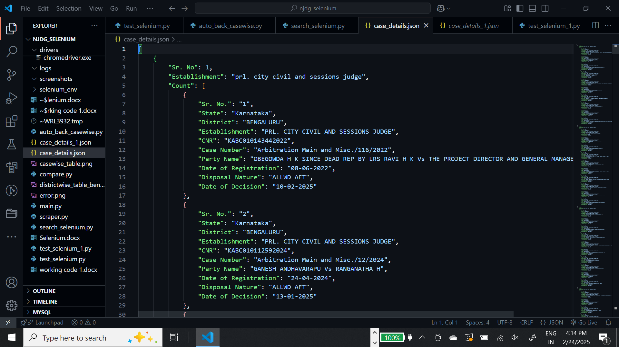

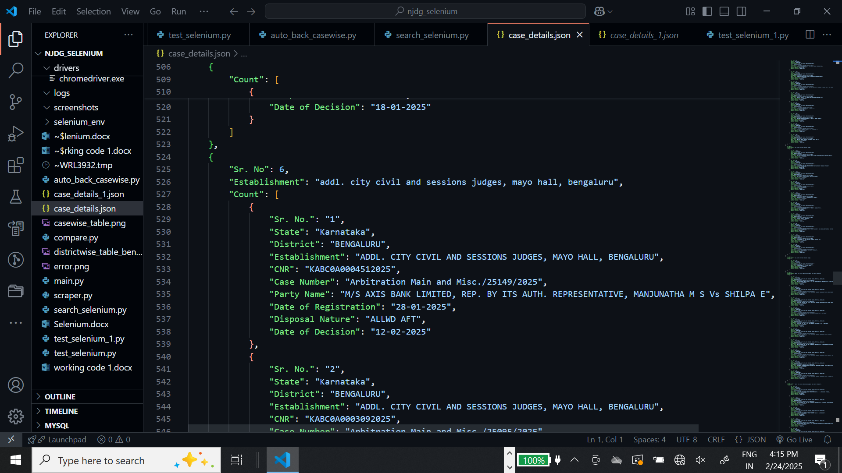

<td class="sorting_1">1</td>

<div class="dataTables_info" id="tblestwisecount_info" role="status" aria-live="polite">Showing 1 to 10 of 11 entries</div>

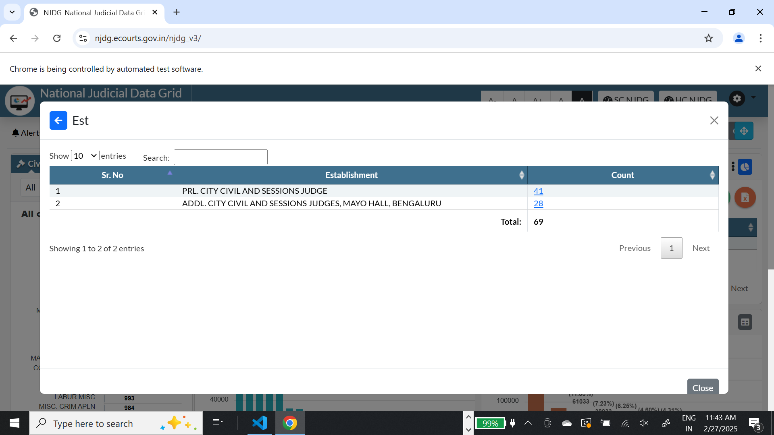

<table id="tblestwisecount" class="table table-bordered bg-light dataTable" style="width: 100%;" aria-describedby="tblestwisecount_info"> <td>PRL. CITY CIVIL AND SESSIONS JUDGE</td>

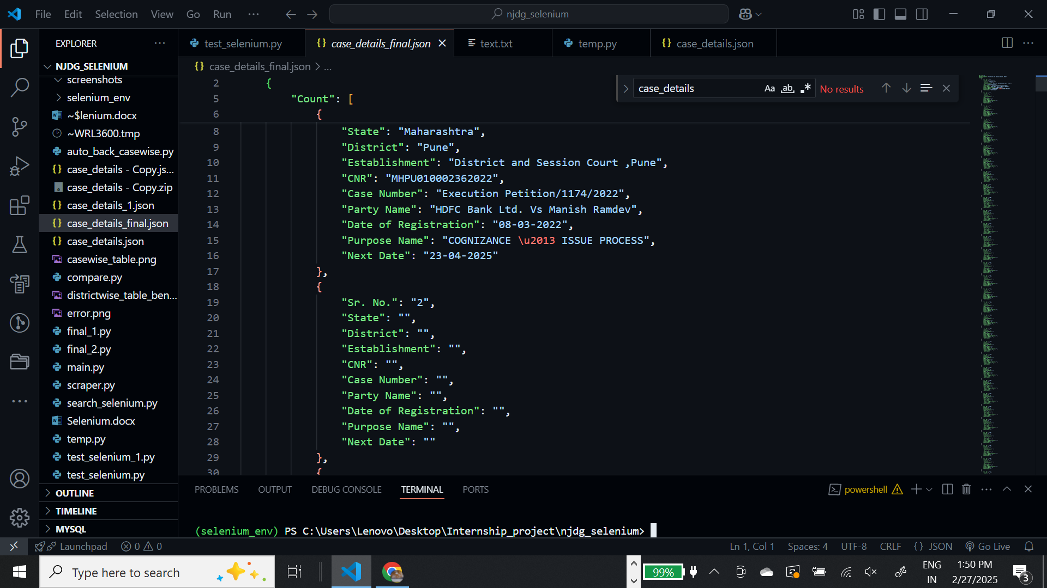

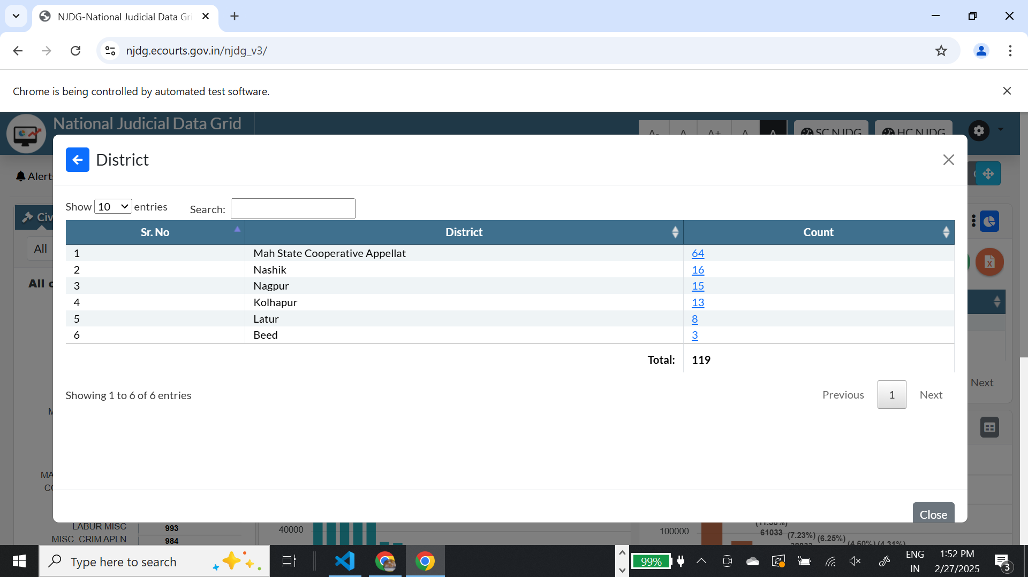

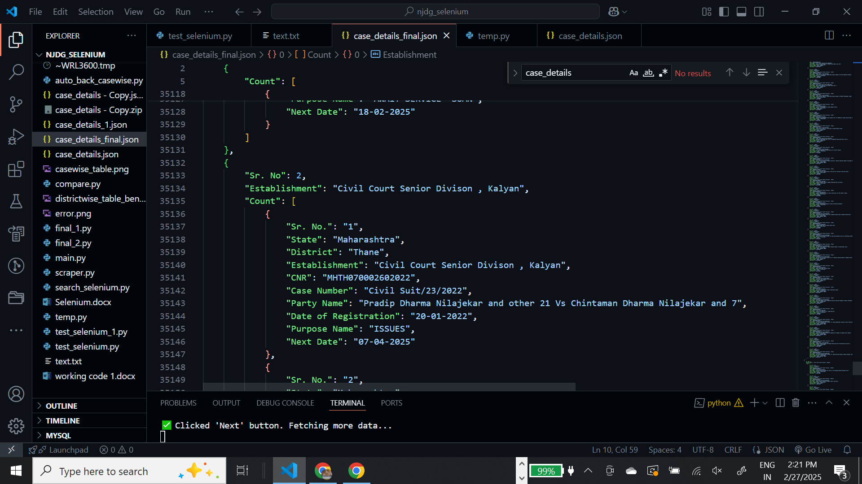

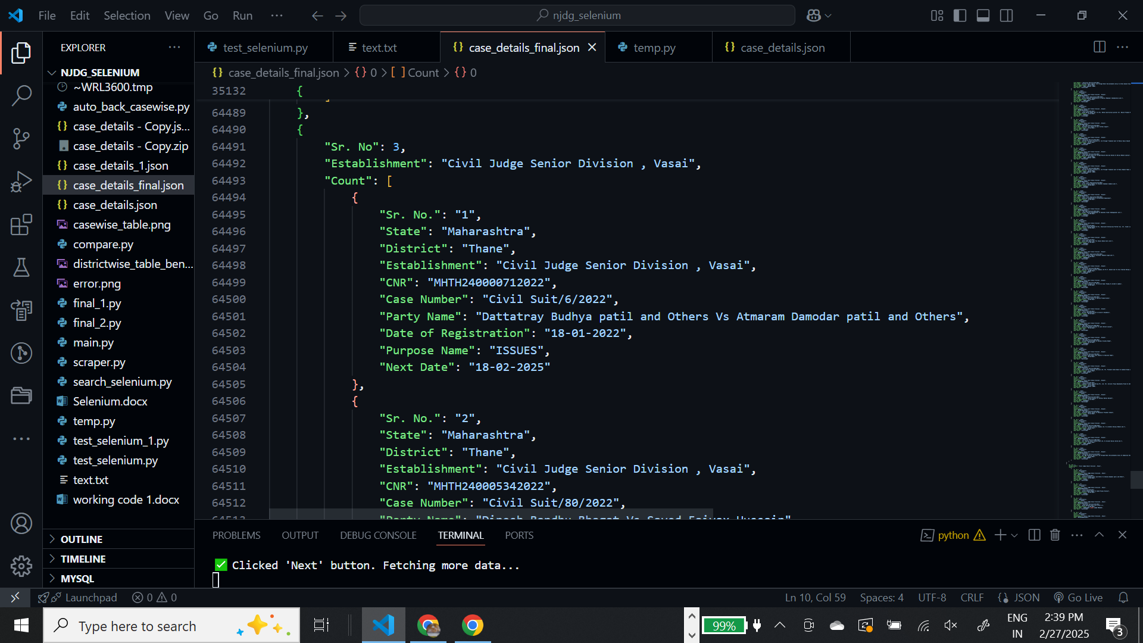

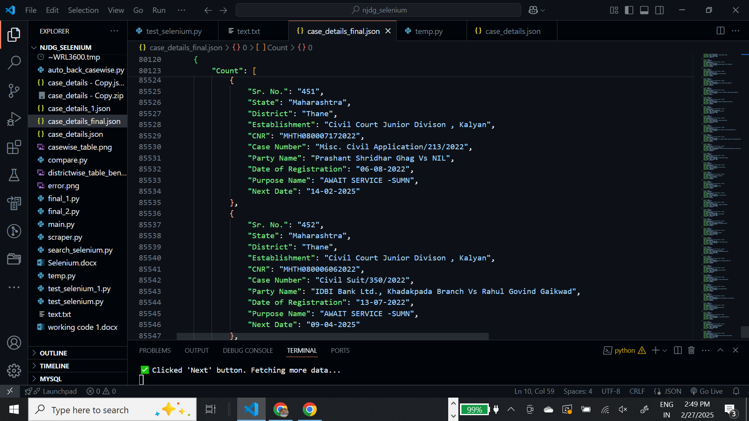

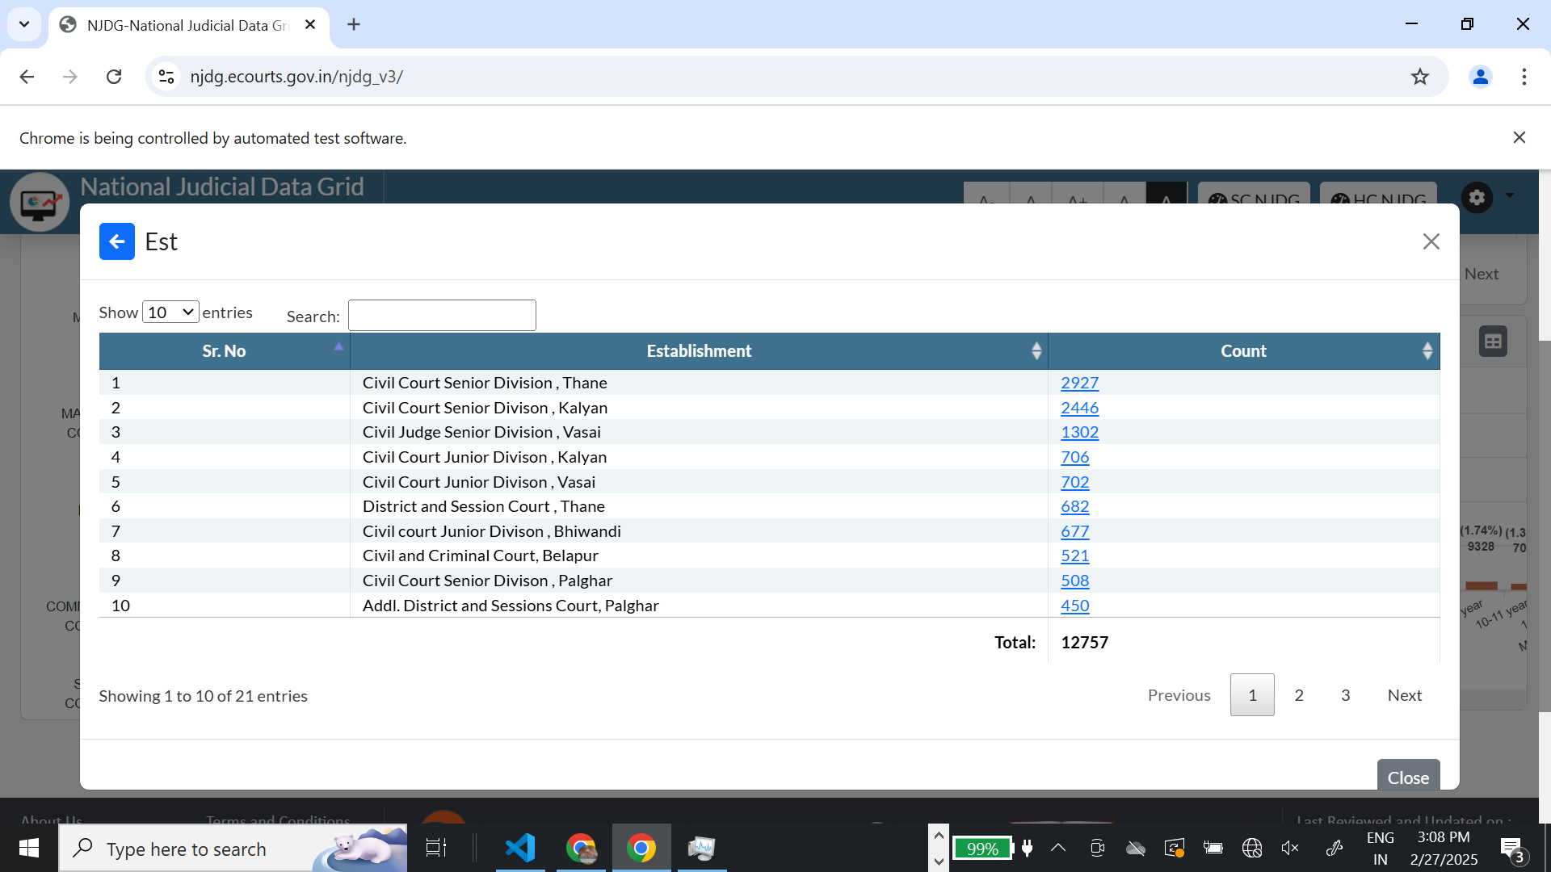

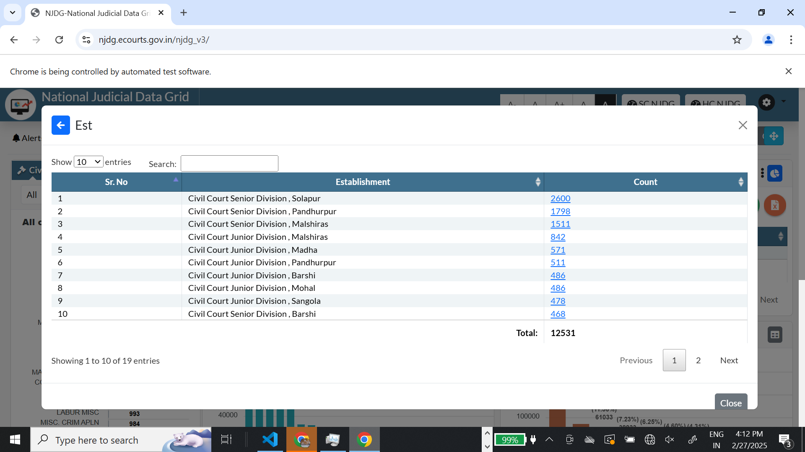

<select name="tblestwisecount_length" aria-controls="tblestwisecount" class>

<option value="100">100</option>slot

<div class="dataTables_length" id="tbldistwisecount_length">

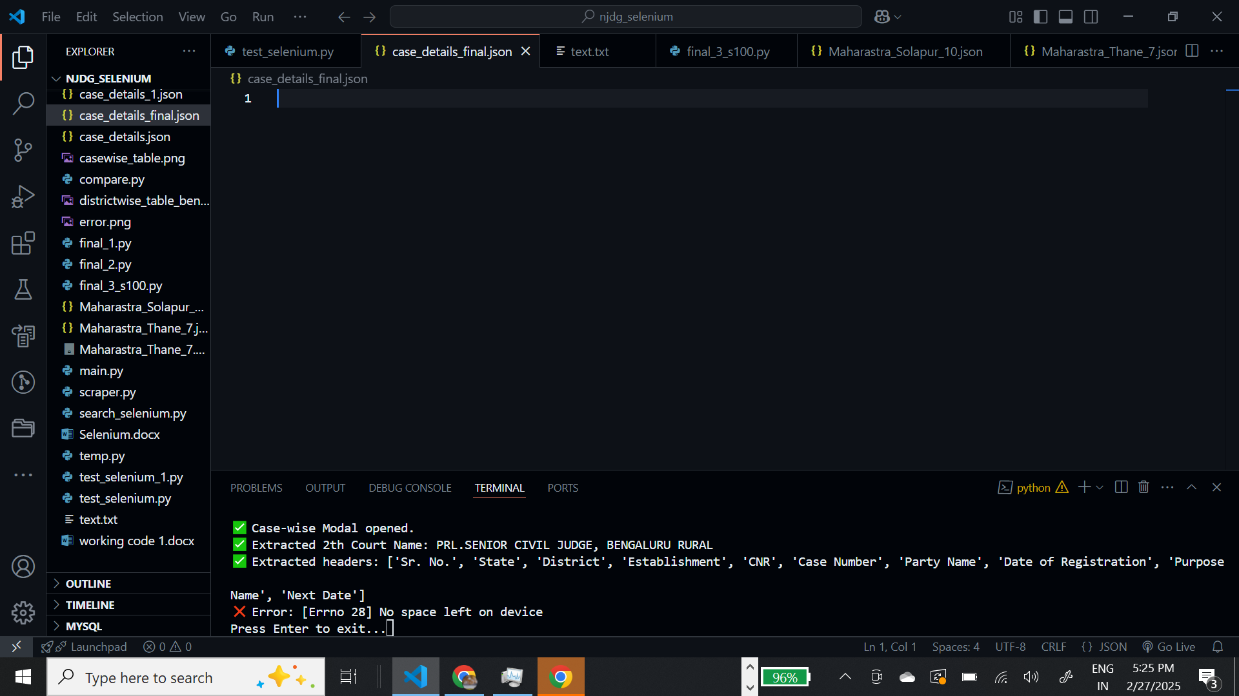

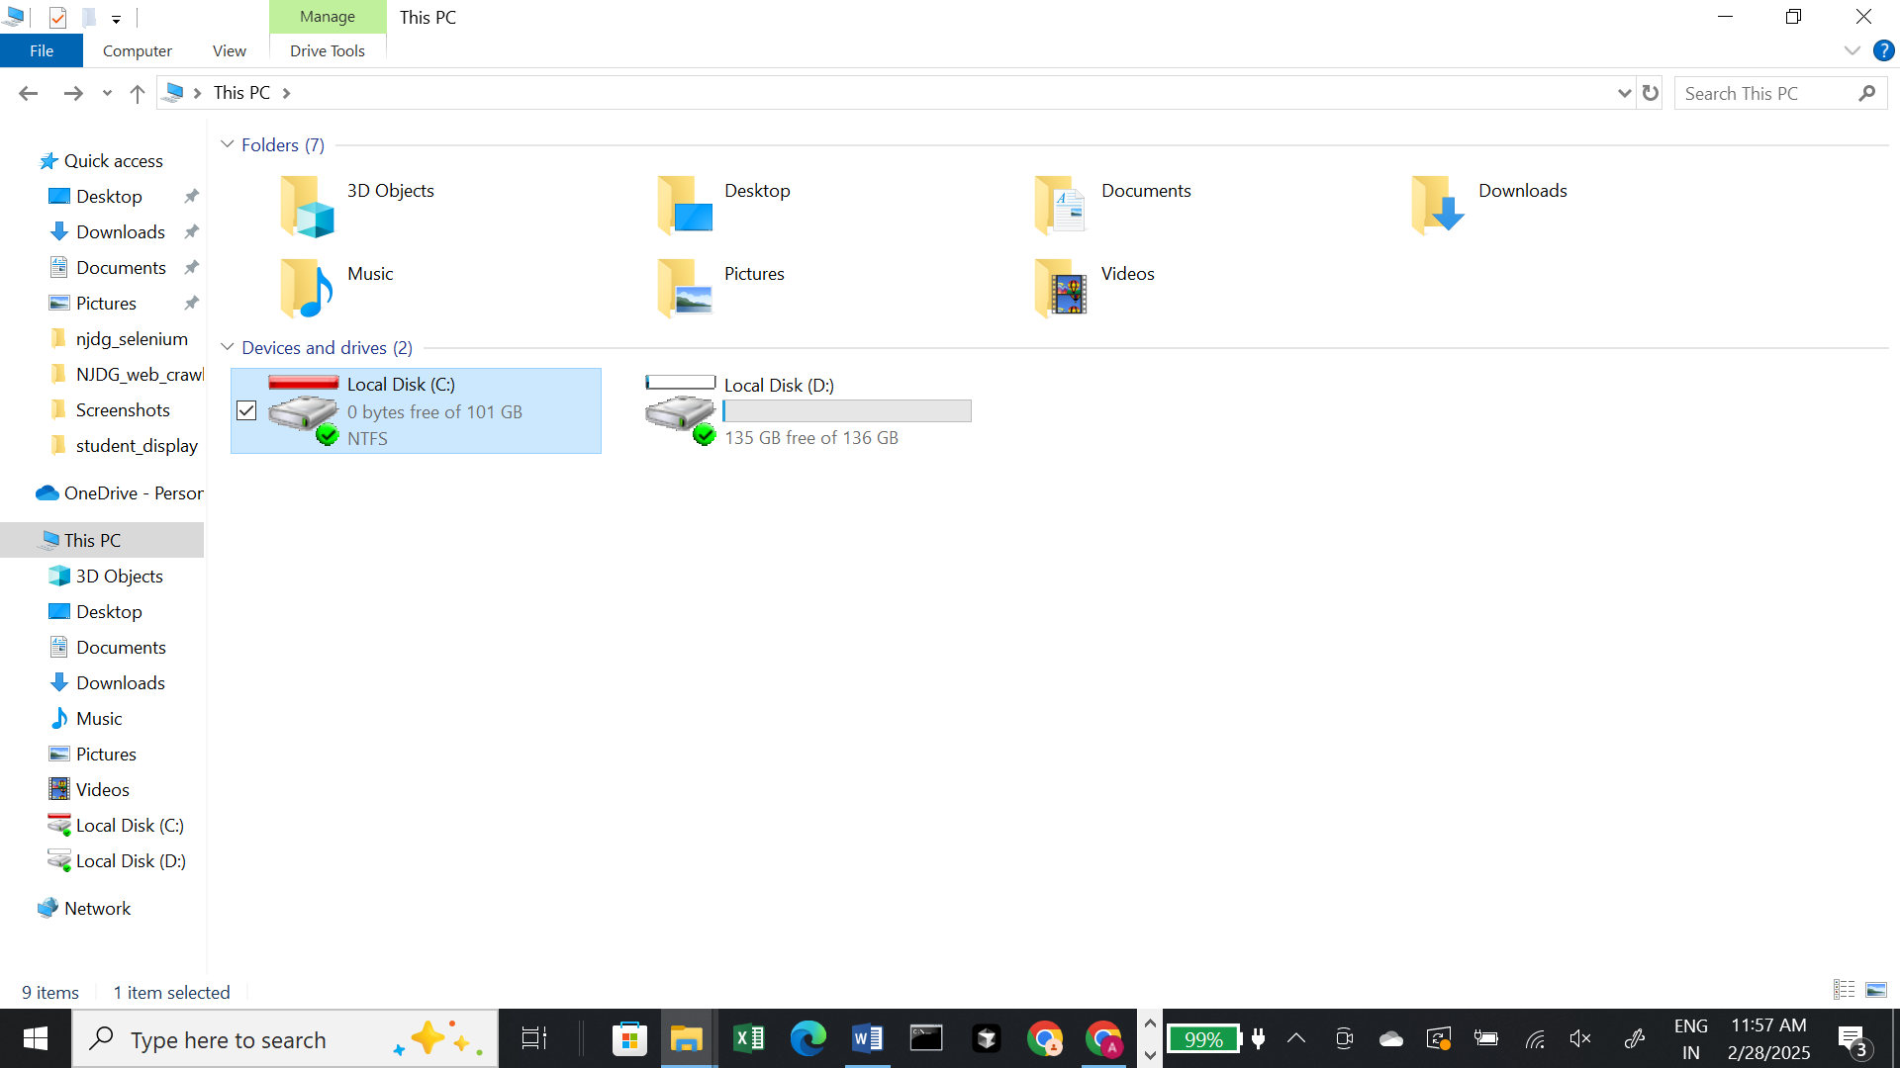

<select name="tbl_cases_dash_length" aria-controls="tbl_cases_dash" class>

<div class="modal-body" id="modal-body-dashcaselist">scroll

<div class="dataTables_info" id="tbl_cases_dash_info" role="status" aria-live="polite">Showing 1 to 10 of 11,255 entries</div>